# 

# INTRODUCTION

***Overview*** : E transport is an android based application made for **Post Lock down Management Of Public Transportation** .

With the help of this application we can Book the tickets , Get the info of the route , take facilities like Health + etcetera .

***Purpose*** : The main purpose of this app is to minimize the physical contact and maintain the social distancing throughout the journey.

This will help us to minimize the spread of virus during travelling from one place to another in public transport.

|  |  |
| --- | --- |
| **LITERATURE SURVEY**  **Existing problem** :  Post lock down period maintaining social distancing will be a chaotic if public transport comes in work . to utilize the capacity of social distancing criteria managing the frequency of buses,trains and metro is important. The transport authorities must integrate to maintain the system properly.  The cash transaction will lead to physical contact that will ultimately lead to spread of the virus.  We often find that the selling of offline tickets will lead to gathering of crowd that will be a failure in achieving social distancing  **Proposed solution** :  **Intelligent Post Lock down Management System For Public Transportation**    Solution Description-   * An android application having two sides one for‘Administration’ and other for ‘User’.      * This app will be especially for Post-Lock down purpose therefore our main aim will be to maintain social distancing and avoiding physical contact.      * The basic idea behind this app will be , to limit the no. of passengers in a particular public transport by limiting the no. of tickets to maintain social distance.      * All the details of Stops and Routes of a particular Metros /Trains/Buses will be available to user through this app.        1. **Solution Approach for Buses/Railways: -**  * Adoption of e-ticketing for buses/railways, no paper ticket would be available.   E-ticketing for a particular bus will start one day before its journey.     * No. of seats in Public bus varies from 50 to 60, equal to total no. of seated passengers.      * No. of seats in a single Railway coach varies from 90 to 100, equal to total no. of seated passengers(Unreserved general class)     The calculation of no. of seats available for a public transport after the post lock down period will be by C.S(calculated seats):  Calculated Seats (C.S) =0.5225*Total no. of seats available   * The maximum number of passengers in bus/Railways in post-lock down period would be equal to C. S , controlled with the help of e-ticketing. This will help in maintaining social distancing as well      * it is the duty of bus conductor/Ticket collector to check the seating arrangement of passengers, who must be siting on alternate seats.        * In case of ticket checking, the staff member can easily scan the QR code on the ticket, with the help of the inbuilt QR code scanner available on administrative side of the app for the verification of passengers .     Novelty/Uniqueness: -   * This app will be fully-featured and user will get the info of 3 most important means of public transport at a single place with E-ticketing facility. * A special feature named as ‘Health+’ makes this app unique and attractive. This feature helps the user to submit any health issue faced during journey. The information would be immediately reported to a nearby hospital and transportation staff members to treat the user accordingly. * As this app encourages E-ticketing therefore there will be no use of paper tickets, staff members would not carry any document or list during ticket checking, scanning of tickets through inbuilt scanner will make their task easy and quick. * even after lock down the app is useful. We just have to change the app variable i.e Calculated Seats       Social/Business Impact: -   * The management of public transport after lock down is challenging issue and might have negative impact on business and social class. we can minimize the impact with the help of properly managed transportation system which will ensure access to workforce,reach supplies and service customers. * **In metros cities like Delhi, which has high use of public transport for regular up and down activities by working class, a manage, planned transportation system will surely support and encourage them.** * Managed Public transport in major metropolitan cities can be the fastest, safest, and cheapest way to connect to work, family, and social activities - facilitating social inclusion and providing additional opportunity especially in Post -Lock down period.  |  | | --- | |  |   An efficient transport system increases safety, improves network efficiency and stimulates intra modality which reduces transport impact on environment and makes cities more attractive.    Technology stack :-   * Languages - Java      * Development Environment – Android studio       Scope of Work: -   * **Description** – First we will develop User side of app then administration side.      * **Modules** –   + User Module –     - It includes development of OTP verified login system for user through Mobile no.     - It includes development secured online Payment system for e-ticketing.     - Information of various public transport for example Live status, routes, no. of stops, availability of seats etcetera will be available.     - It also includes development of Health+ Facility Tab. * Administrative Module-   + It includes development of secured login system for government staff through IDs.   + It also includes development of barcode scanner for ticket verification.   + Updating and checking the information of public transport by staff members through this module and regular check on Health+ facility tab submissions nu user.                    Dependencies |

implementation 'com.google.firebase:firebase-analytics:17.4.3'  
 implementation 'androidx.constraint layout:constraint layout:1.1.3'  
 implementation 'com.google.firebase:firebase-database:19.3.0'  
 implementation 'com.google.firebase:firebase-auth:19.3.1'  
 implementation 'com.google.firebase:firebase-storage:19.1.1'  
 implementation 'com.google.firebase:firebase-firestore:21.4.3'  
 implementation 'androidx.multidex:multidex:2.0.1'  
 implementation 'com.toptoche.searchablespinner:searchablespinnerlibrarimplementation 'com.google.android.material:material:1.1.0'  
 implementation "com.airbnb.android:lottie:3.4.1"  
 implementation fileTree(dir: "libs", include: ["*.jar"])  
 implementation 'androidx.appcompat:appcompat:1.1.0'  
 y:1.3.1'  
 implementation 'com.firebaseui:firebase-ui-firestore:4.3.1'  
 implementation 'com.google.zxing:core:3.2.1'  
 implementation 'com.journeyapps:zxing-android-embedded:3.2.0@aar'  
 testImplementation 'junit:junit:4.12'  
 implementation 'com.google.android.gms:play-services-auth:16.0.0'  
 implementation 'me.dm7.barcodescanner:zxing:1.9'  
 androidTestImplementation 'androidx.test.ext:junit:1.1.1'  
 androidTestImplementation 'androidx.test.espresso:espresso-core:3.2.0'

* **First week of the project**
* Started working on 9th June 2020 . We created the git repository and upload the basic application code on git hub.
* On the 10th of June we started creating the frontend of user phase using android studio.We created Java file and the XML files for the processing page.

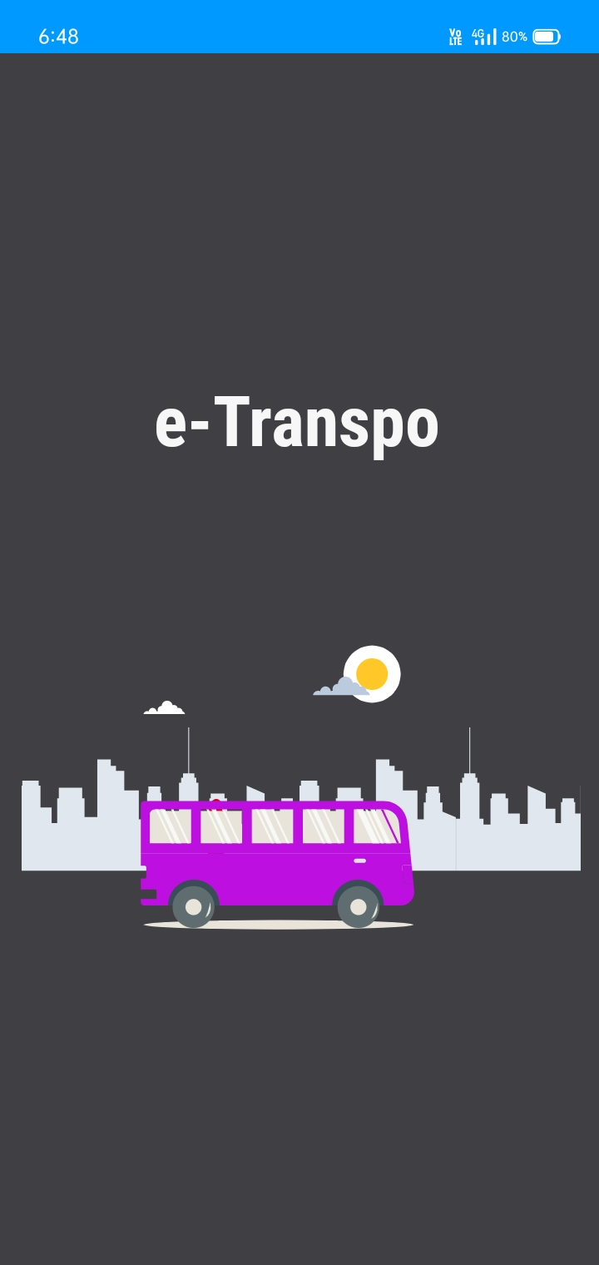

* On June we created the sign up ,login and dashboard page of the user phase.We used the Firebase services for the database

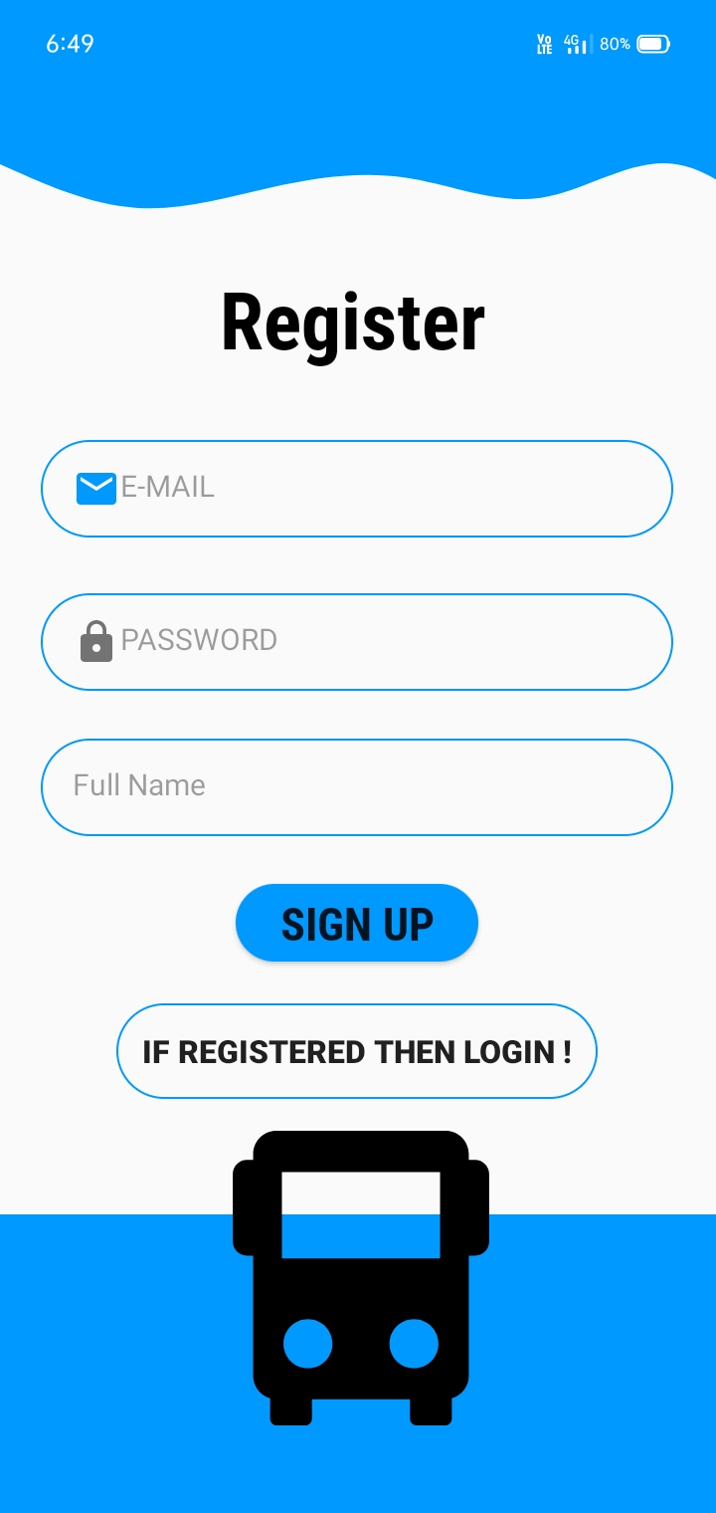

* We created the Pages like health +, book tickets,mode of transport.

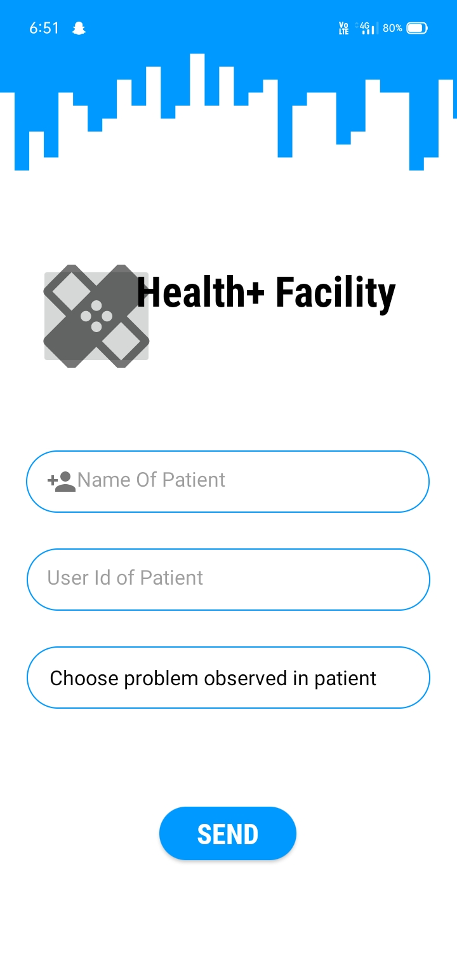

* On 13th of June we have completed our frontend for the user phase.

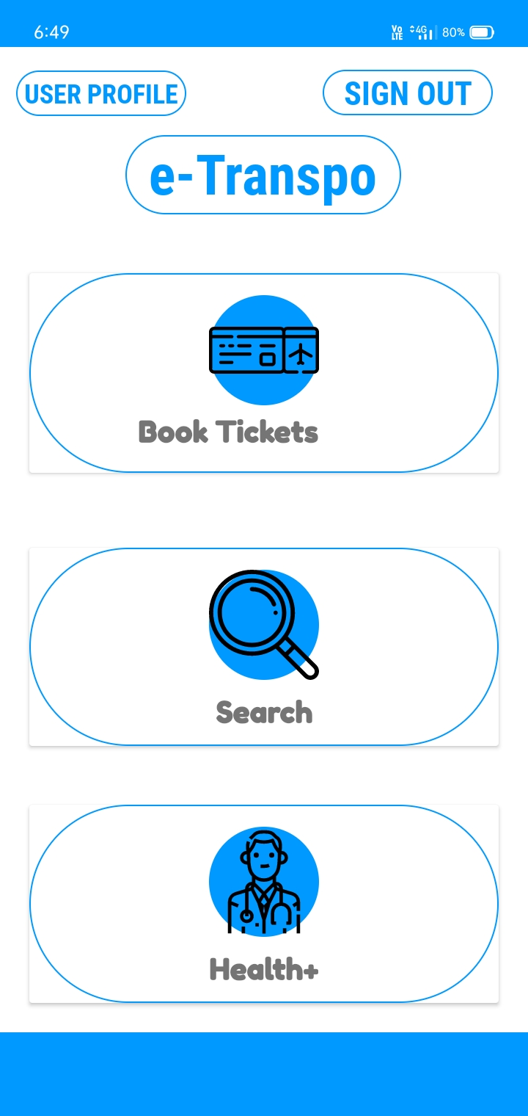

* On 14th of June we started working in the backend of the application .

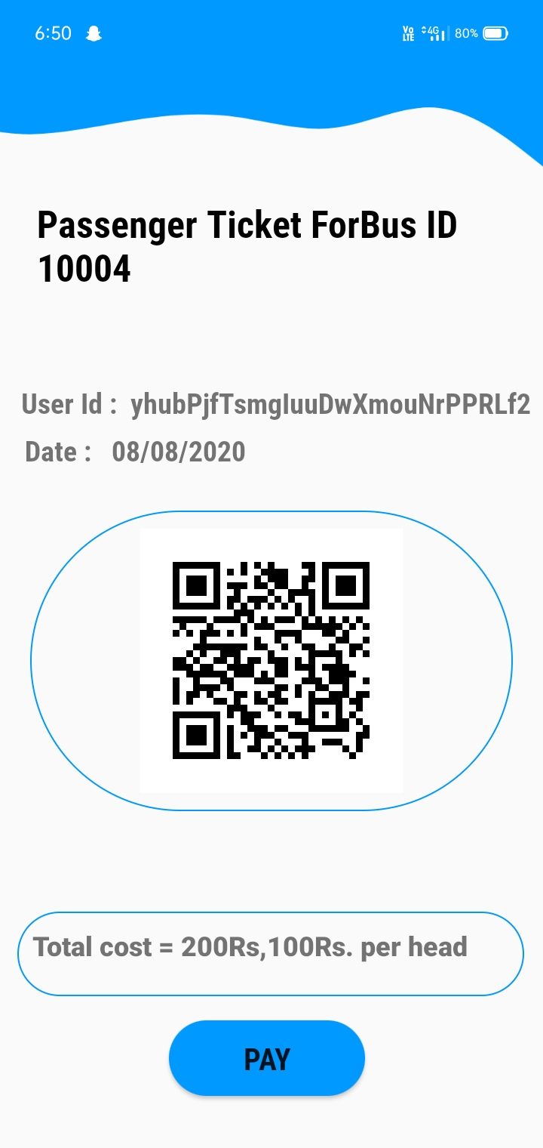

* In the days followed we checked the proper functioning of sign up - login pages,booking tickets between station .
* on the next day ticket in the form of pdf were generate along with a barcode.
* **Second week of the project**
* We created the admin phase login, sign up page UI . Firebase services helps in creation of Database.

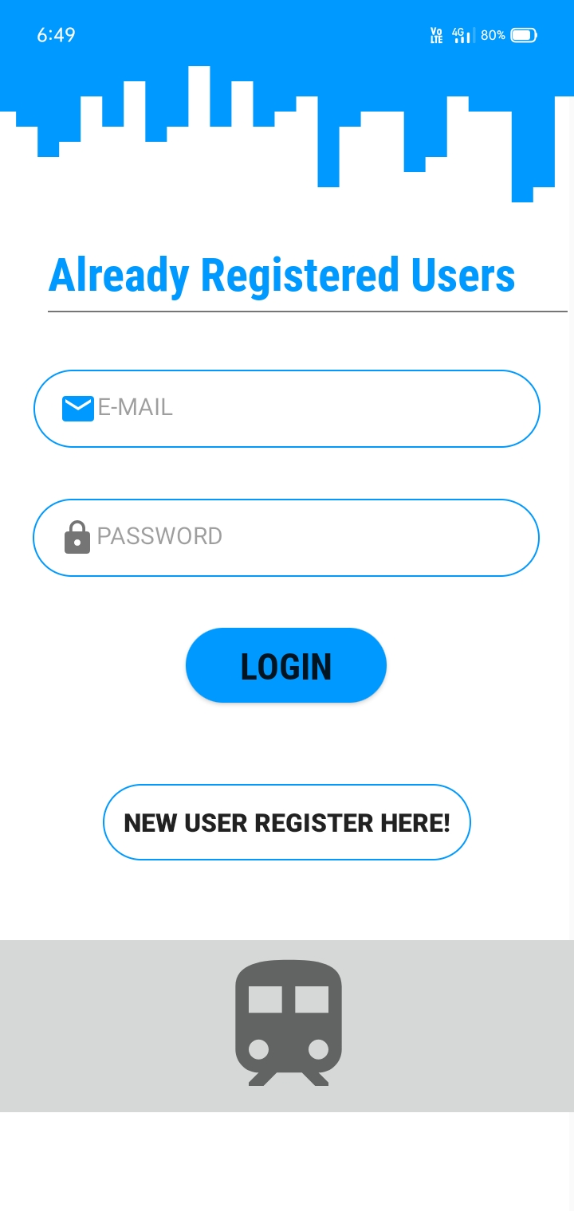

* Then on the following day we created the admin phase dashboard.

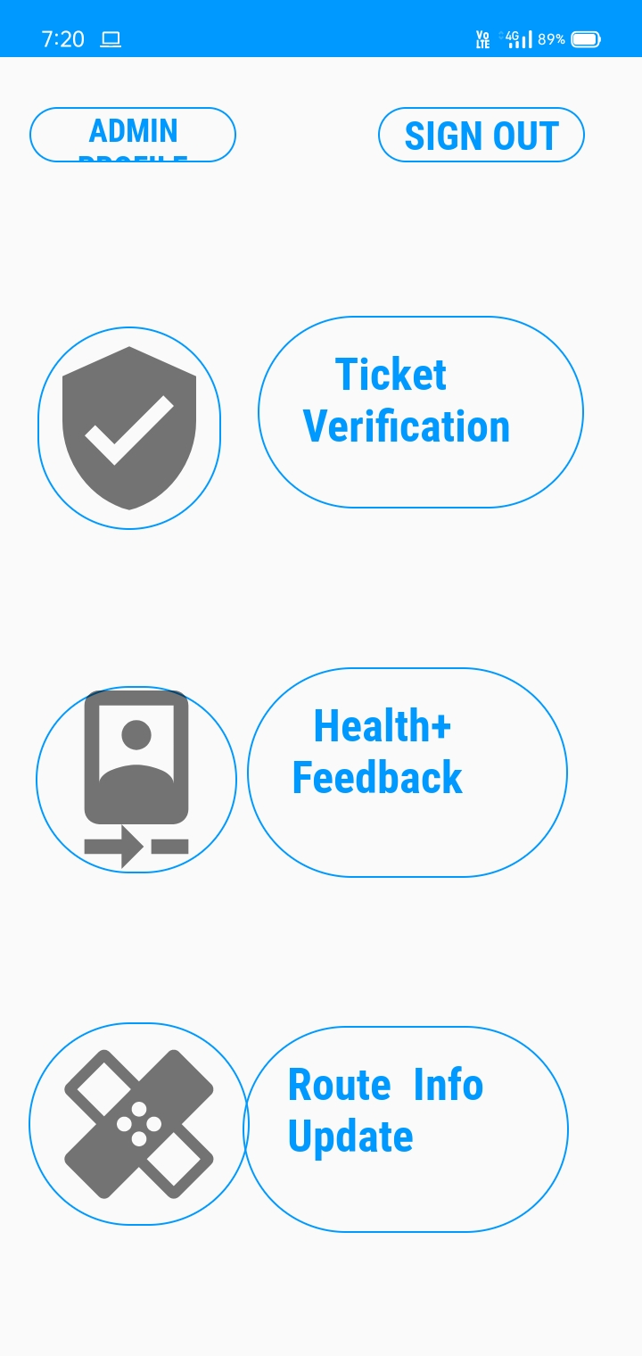

* We created the barcode scanner .So that staff member can verify the tickets.

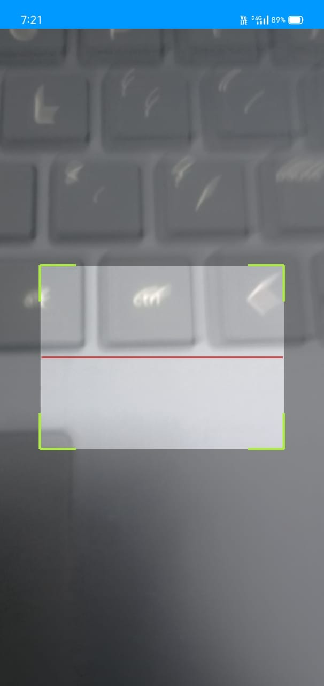 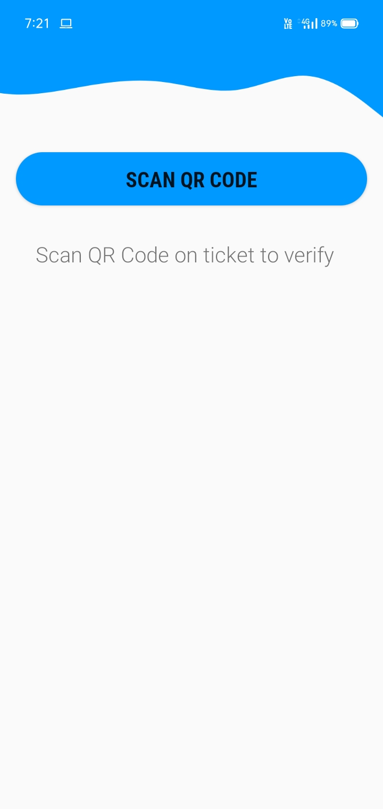

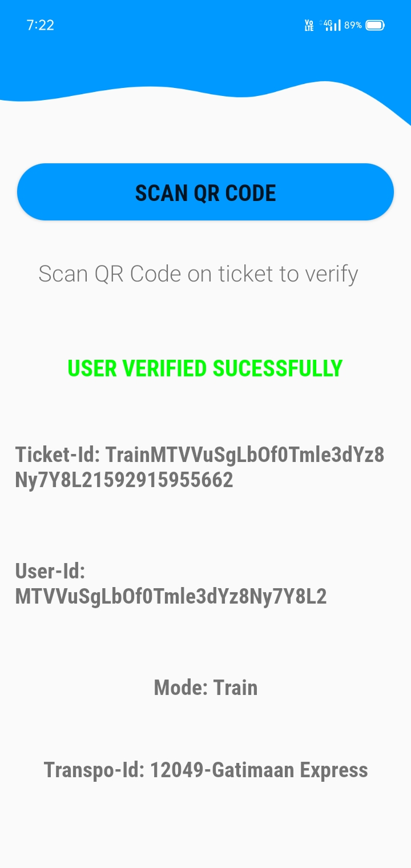

* Backend for the admin phase so that admin

phase commands works efficiently was

written in the following days.

Staff members can scan the barcode from

the ticket pdf of the consumer.

{{Fullname:Recipient1}}

* Generation of Health + Feedback form .

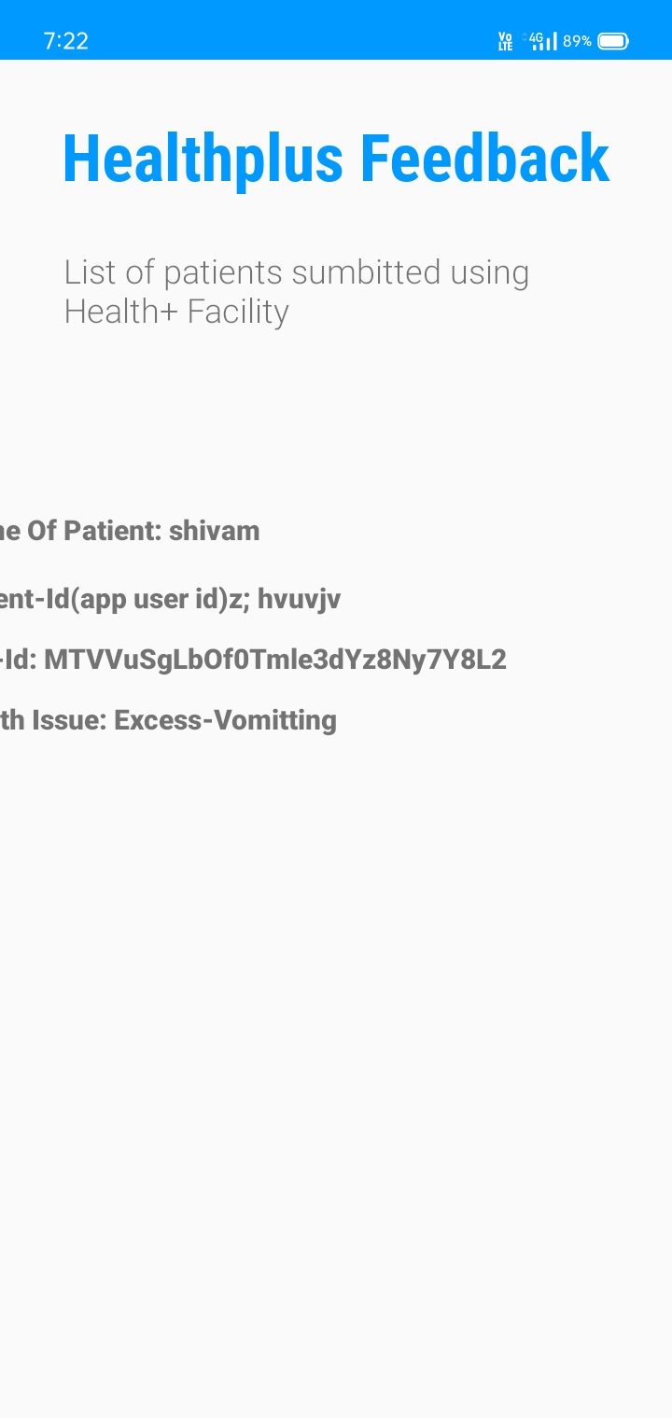

# Conclusion :

By creating this app we ensure the minimal physical contact as there will be online .Transactions there will be no physical contact ensuring the social distancing.

We have pre installed an algorithm according to which only a limited number seats will be available for booking.

To avoid any physical contact bar scanner is useful as it checks the tickets.

# Future Scope :

until now it was due to unavailability of database and api of various public transport. Availability of api can help to take the whole public transport management of the country with a single app.

# BIBILOGRAPHY

**Freecodecamp.org** : Android Development for Beginners - Full Course

<https://www.youtube.com/watch?v=fis26HvvDII&t=1s>

**Cronocode** : Android UI material design

<https://www.youtube.com/watch?v=hAdW6YRCCIA&t=17s>

# Appendix:

[Source code](https://github.com/SmartPracticeschool/SBSPS-Challenge-769-Post-Lockdown-Public-Transport-Management-System.git) :You can find the whole source code for the app in this git repository.